Invitation for Bid
TNC-KH-KAʻŪ-FENCES-25
Fence Installation and Replacement in the Kona Hema Preserve and Kaʻū Preserve
Hawaiʻi Island

OVERVIEW
The State of Hawaiʻi’s Division of Forestry and Wildlife (DOFAW) is seeking bids for constructing ungulate-proof fences, as well as associated tasks such as clearing the fence corridor, removal and disposal of old fence wire, and installing pedestrian and vehicle gates as needed:
1) Kona Hema Preserve fence segment replacements in the Honomalino and Pāpā Management Units: Pāpā North, Pāpā Mauka, and Honomalino Mauka. New Fence construction Hoʻopuloa North in the Hoʻopuloa management unit (Figures 1, 2 & 3)
2) Kaʻū Preserve fence segment replacement in the Makaʻālia Management Unit, including new construction of two fence “spurs” (Figures 1, 4 & 5).
Bidders have the option of bidding on one project, or both. The method of award will be for the lowest bidder on each job. Therefore, the successful bidder(s) will enter a contract with the State of Hawaiʻi from which fence projects will be executed with a State of Hawaiʻi Purchase Order (PO).
The bidder will also provide a performance bond and a payment bond to ensure completion of all portions of the project to the specifications herein and payment of any materials, or labor debts.
Voluntary Pre-Bid Conference: Meeting for Kona Hema will take place on September 30, 2025 at 8 AM just mauka of the intersection of Highway 11 at the turn-off to Honomalino Road in South Kona. Here is a google maps point for the meeting location. Meeting for Kaʻū will take place on October 1, 2025 at 8 AM at The Nature Conservancy’s (TNC) Kaʻū Field Office, 95-6006 Mamalahoa Hwy Naalehu, HI. 96772.
You will need a 4WD vehicle to access the project site(s) for the Pre-Bid Conference. Due to steep terrain, not all sections of the projects are accessible with 4WD trucks, so bring sturdy hiking shoes and drinking water if you would like to inspect all sections. Be prepared for hot and/or rainy weather at an elevation of approximately 2,000 to 5,500 feet (Kona Hema) and 2,000 to 4,500 feet (Kaʻū).

As a courtesy, please contact the Contractor Administrator, at least one day prior to the meeting if you would like to participate. Bidders are strongly advised to inspect the general fencing area prior to submitting a proposal. Forest habitat can be examined by doing a “fly-over” of the fence installation site at the bidder’s expense. Geographic Information System (GIS) shapefiles of the fenceline are available here: https://tnc.box.com/s/lfxrog5exhyhdihiltkwr9ft8h91zsqe. Topographic and logistic conditions present difficulties that are not typical for fence installation projects. Failure to visit the work area/installation site will in no way relieve the successful bidder from completion of the work in accordance with the specifications, terms, and conditions herein to the satisfaction of the Contracting Officer’s Representative.

Schedule of Key Dates: Tables 1 and 2 below represents DOFAW’s best estimate of the schedule for each project. If a component of this schedule is delayed, the rest of the schedule will be adjusted accordingly.

Table 1: Kona Hema Key Dates
Voluntary Fence Pre-Bid Conference | September 30, 2025
Deadline to Submit Written Inquiries/Questions* | October 6, 2025
DOFAW’s Response to Written Questions | October 10, 2025
Deadline to Submit Bid** | October 20, 2025

Table 2: Kaʻū Key Dates
Voluntary Fence Pre-Bid Conference | October 1, 2025
Deadline to Submit Written Inquiries/Questions* | October 6, 2025
DOFAW’s Response to Written Questions | October 10, 2025
Deadline to Submit Bid** | October 20, 2025

The contract signing and Purchase Order process may take a few months after the bids are due. The State must also receive and stage the materials before construction begins. Note that the estimated date for construction to start is December 2025. If the materials are delivered early, the State will notify the contractor, and they may begin earlier if they want to.

*Questions should be submitted to the Contract Administrator.

**Offers must be submitted through the State of Hawaiʻi eProcurement (HIePRO) system.

SCOPE OF WORK
The objective is to protect and preserve land in the Kona Hema and Kaʻū Preserves by preventing the ingress of feral ungulates onto the properties. The project areas are owned and managed by TNC.
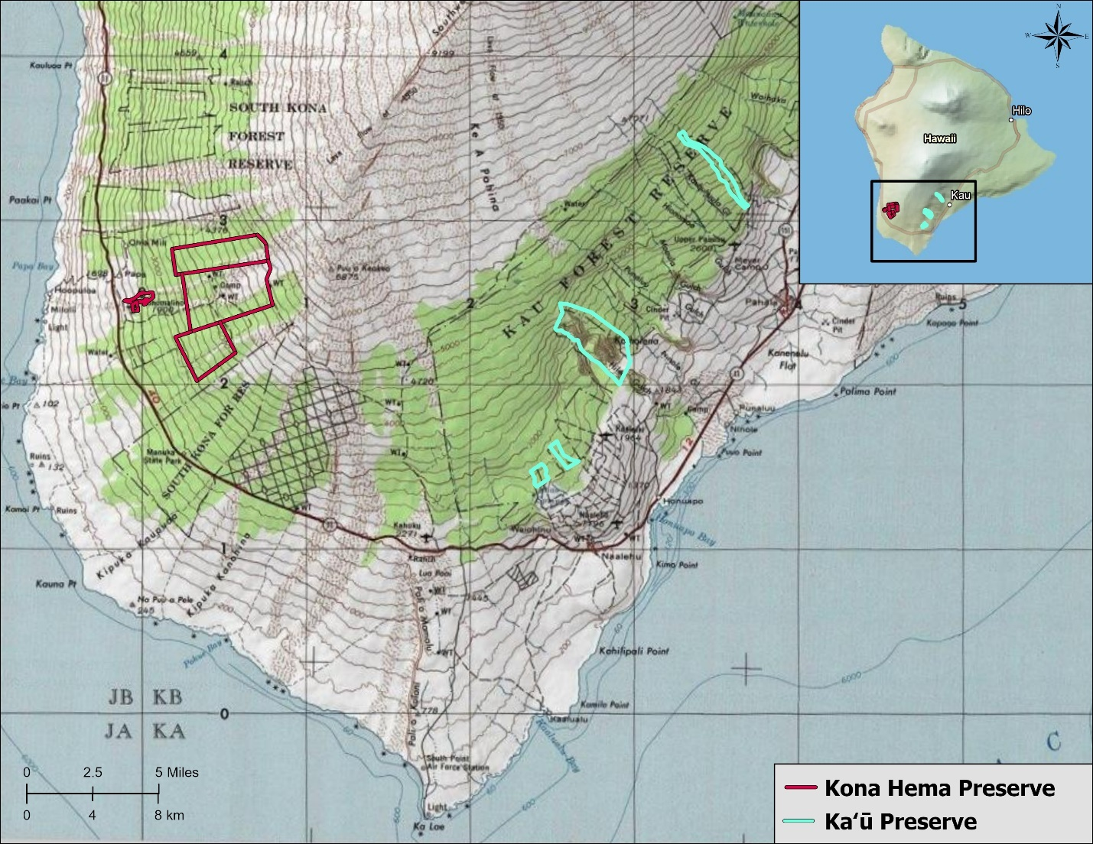
Figure 1: TNC Above mentioned preserve locations, Hawaiʻi island.

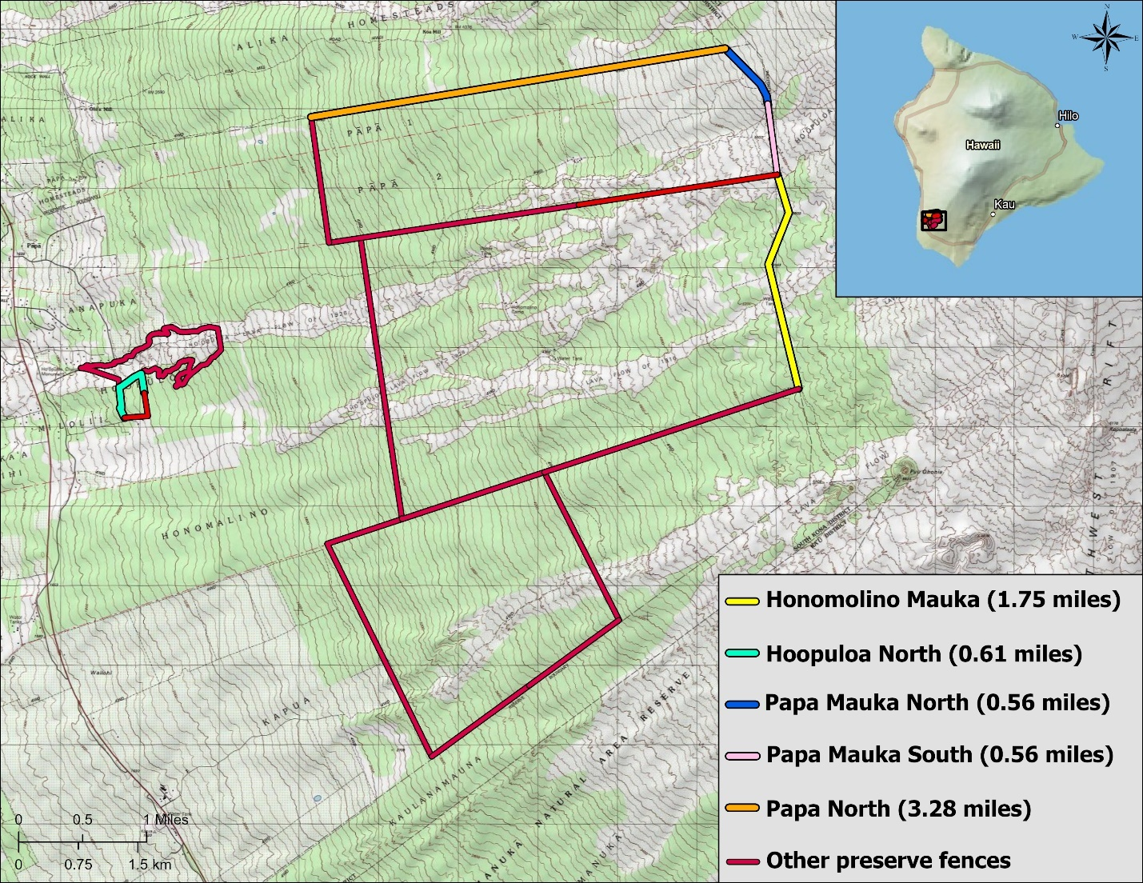
Figure 2: Kona Hema fence segments. Note Pāpā North, Pāpā Mauka North, Upper Pāpā South, and Honomalino Mauka are replacement fences.
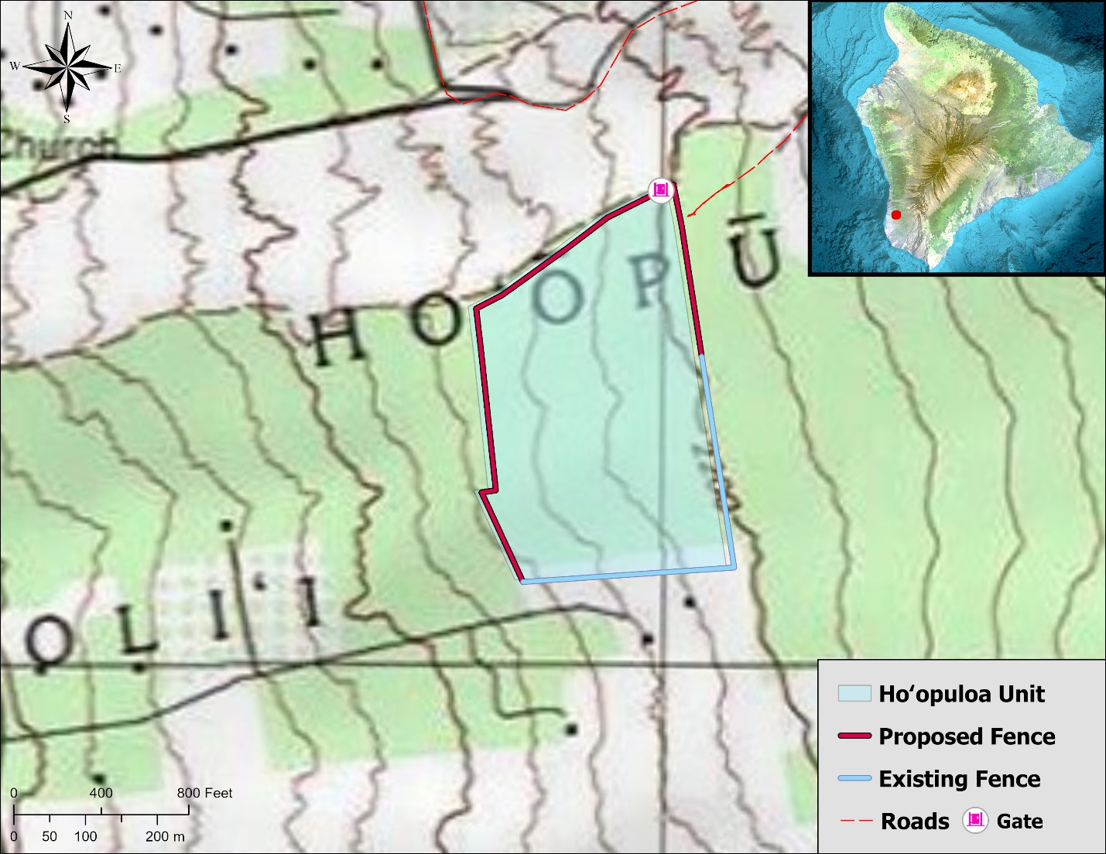
Figure 3: Hoʻopuloa North new fence construction.
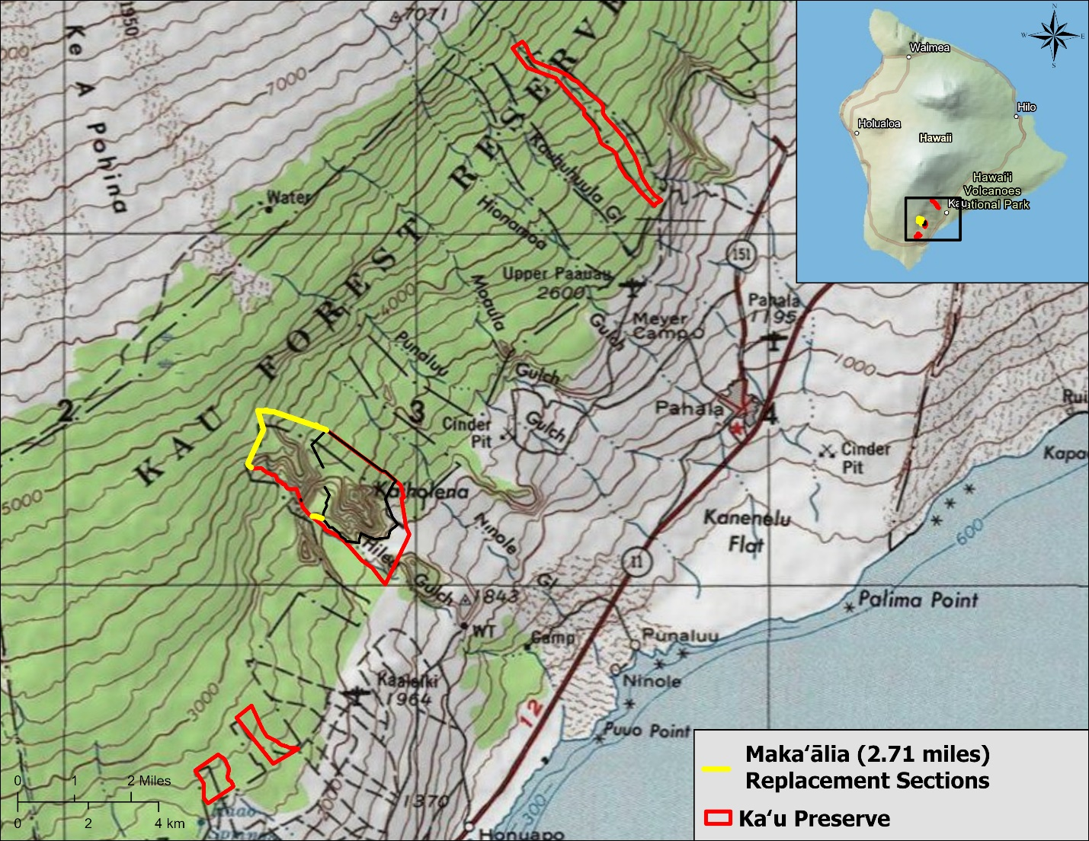
Figure 4: Kaʻū Preserve, fence sections in yellow to be replaced.
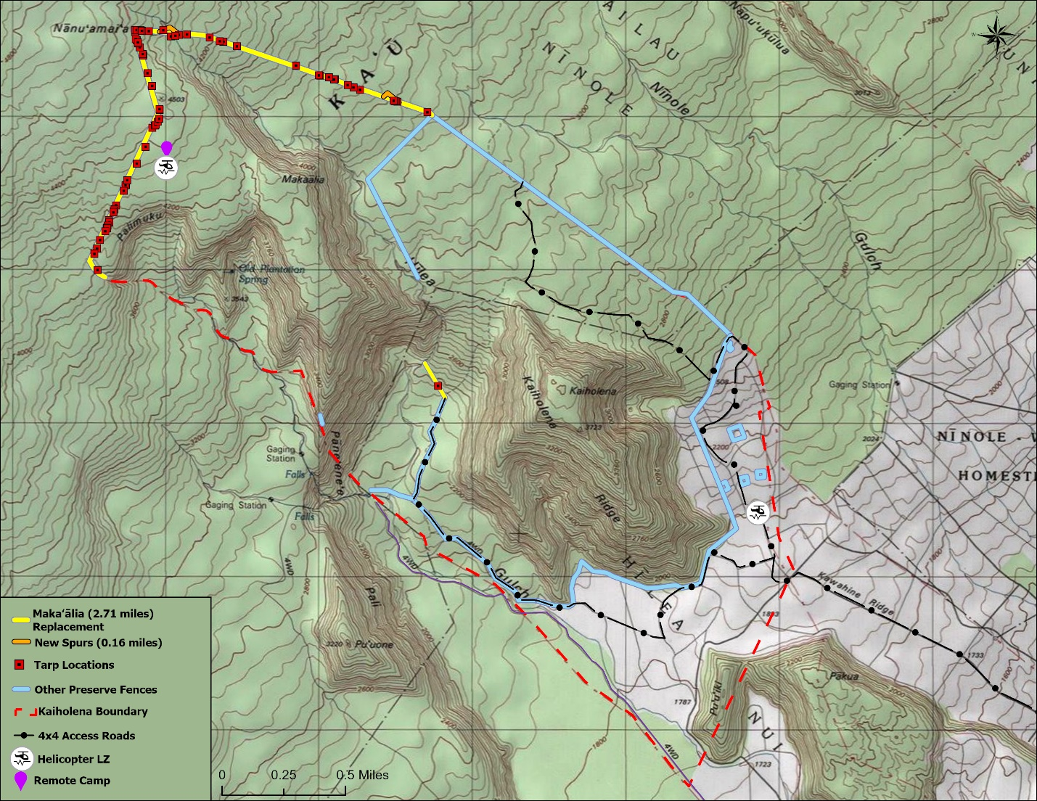
Figure 5: Kaiholena and Makaʻālia Management Unit Fences in the Kaʻū Preserve.

Minimum Qualifications:
To be considered for this contract award, an Offeror must meet the following minimum qualification:
Must be familiar with installation of ungulate-proof fencing in remote areas with rough lava terrain
and have had related project experience in Hawaiʻi. Offeror shall provide in their proposal a
description of and references from at least two (2) feral-ungulate-proof (e.g. pig, goat, sheep or
deer) fence installation projects in remote areas in the State of Hawaiʻi of at least 5,000 linear feet (LF) each.

TNC’s Kona Hema Preserve Fence Project Details:
In the Hoʻopuloa Management Unit (TMKs (3) 8-9-001:016 (por.)), the contractor will brush, clear and construct approximately 0.61 miles or 3,234 LF of the remote Hoʻopuloa North fence segment (No adjacent road).
In the Pāpā Management Unit (TMK (3) 8-8-001:001 (por.)), the contractor will replace approximately 4.40 miles or 23,217 LF of fence wire (and anchors, when needed) on the Pāpā North, Pāpā Mauka North, and Upper Pāpā South fence segments. All old fence materials will be removed and disposed of by the Contractor.
In the Honomalino Management Unit (TMK (3) 8-9-001:001 (por.)), the contractor will replace approximately 1.75 miles or 9,214 LF of fence wire (and anchors, when needed) on the Honomalino Mauka fence segment. All old fence materials will be removed and disposed of by the Contractor.
TNC’s Kaʻū Preserve Fence Project Details:
In the Makaʻālia Management Unit (TMKs (3) 9-7-001:004 (por.) and (3) 9-7-001:001 (por.)), the contractor will replace approximately 2.75 miles or 14,520 LF of fence wire (and corner posts, anchors, and tarps where needed) on the Makaʻālia Hilo, Makaʻālia, and brush, clear and construct Makaʻālia Spur 1, and Makaʻālia Spur 2 fence segments. All old fence materials will be removed and disposed of by the Contractor.

For both projects, minor changes in the fence alignment may be made due to terrain or avoidance of sensitive features, such as the identification of endangered plants and/or archaeological features. The State reserves the right to purchase larger or smaller quantities at the per linear foot price quoted on the OFFER FORM page.
Access to Kona Hema Preserve:
Access to Kona Hema is over 4x4 lava roadways and pasture, and therefore, does not require a helicopter. The project area is located on private TNC land, and entry into the area requires keys issued by TNC. The Contractor will take responsibility for all keys issued during fence installation. The Department currently has a Right of Entry to the private lands where fence construction will take place. Contractors are required to have sufficient insurance coverage required by TNC before project start. The Contractor will notify DOFAW and TNC of the dates of access in advance, and coordinating use of their access roads that may help with the project.
Specific areas of the Hoʻopuloa Management Unit can be accessed by different modes of transportation.There are access roads that run adjacent to one side of the proposed fenceline and not all sections are accessible with trucks and equipment due to loose substrate and steep slopes. Along the project there are numerous locations for parking vehicles, equipment, and material. Each parking area shall be mowed or otherwise prepared by the Contractor to eliminate fire threat from pasture grasses being in proximity to hot surfaces.

The lava flow located in the Ho‘opuloa Management Unit may be used as a helicopter landing zone and material staging area.

The Contractor is advised that this project occurs adjacent to an active cattle ranch. When working on this project, contractor must maintain contact with Contractor Administrator and TNC staff to avoid conflicts with Hoʻomau Ranch’s operations. Contractors shall access the site with vehicles in good operating condition that are not prone to overheating and must be equipped with portable fire extinguishers. All vehicles entering the property must be clean and free from any offsite mud, dirt, debris, insects that may introduce unwanted pests onto the property.

Access to Kaʻū Preserve:
Access to the fencing sites is over 4x4 lava roadways, pasture and hiking trails. The project area is located on private TNC land, and entry into the area requires keys issued by TNC. The Contractor will take responsibility for all keys issued during fence installation. The Department currently has a Right of Entry to the private lands where fence construction will take place. Contractors are required to have sufficient insurance coverage required by TNC before project start. The Contractor will notify DOFAW and the landowner of the dates of access in advance. Access to the fence installation sites from the main route is by 4wd roads, on foot, and by way of established helicopter landing zones (See Figure 5).
Specific areas of the Makaʻālia fence project can be accessed by different modes of transportation.
There are access roads that terminate within 2,000 feet of the proposed fenceline with all sections accessible only on foot. This staging area, along with a helicopter landing zone located within the pasture area of the same property, are locations for parking vehicles, equipment, and material. Each parking area shall be mowed or otherwise prepared by the Contractor to eliminate fire threat from pasture grasses being in proximity to hot surfaces. Keys will be needed to access the project site, with keys being available for pickup from TNC. The contractor is responsible for contacting and coordinating with the DOFAW and TNC for use of their access roads that may help with the project.
The Contractor is advised that this project occurs within an active cattle ranch. When working on this project, contractor must maintain contact with Contractor Administrator and TNC staff to avoid conflicts with MJ Ranch’s operations. Contractors shall access the site with vehicles in good operating condition that are not prone to overheating and must be equipped with portable fire extinguishers. All vehicles entering the property must be clean and free from any offsite mud, dirt, debris, insects that may introduce unwanted pests onto the property.
The Contractor shall be responsible for transporting all required fence tools, work crew, and equipment to the installation sites. Equipment may be stored on-site at the Contractorʻs own risk. The Contractor will deliver fence materials from the DOFAW baseyard in Waimea to specified staging areas within the work area. The Contractor will disperse materials from the material staging areas to the installation sites. DOFAW will not provide any helicopter transport for the Contractor’s crew or material. The Contractor shall coordinate its work schedules, timing and other relevant communications directly with the Helicopter Contractor; however, the State’s Contract Administrator shall be notified at least 5 days in advance of proposed work and flight schedules and included in pertinent communications affecting the project. The Contractor must complete full walk through with a State representative prior to commencing.
Terrain:
The Kona Hema Preserve is on TNC lands in the South Kona district of Hawai‘i Island. The project area ranges between approximately 2,080 and 5,500 feet in elevation. This area receives approximately 60 inches of rainfall per year and is predominately ‘ōhi‘a seasonal mesic forest. The ground can be loose lava, solid rock, or stony mud.
The Kaʻū Preserve is on TNC lands in the Kaʻū district of Hawaiʻi Island. The project area ranges between approximately 3,200 and 4,500 feet in elevation. This area receives approximately 90 to 120 inches of rainfall per year. The area is predominately ‘ōhi‘a-hāpuʻu lowland wet to montane forest. The ground can be loose lava, solid rock, or stony mud. The majority of the fence alignment crosses relatively young a‘a lava terrain where water courses and washouts have undermined the existing fence.
Site preparation:
The fence corridor will be delineated and flagged by TNC. The Contractor shall be responsible for brushing a fence corridor; fence construction and post construction clean up. It is recognized that for installation purposes, the Contractor may choose to shift the flagged alignment slightly. The fence alignment may need adjusting prior to and/or during corridor clearing, and only after consultation with DOFAW or DOFAW’s representative. Upon approval, the Contractor may re-align the fence to straighten alignments, to adjust corners, to avoid certain trees and shrubs, to avoid any rare plants or potential archaeological structures. The Contractor shall be responsible for brushing (removing) some vegetation on either side of the final or corrected fence alignment (no more than ten feet total) as the fence shall be constructed at the midpoint. This may include some shrubs, ferns and both non-native and native vegetation. Brushing of plants along the fence corridor should only remove those plants that may hinder fence construction or future fence inspections, such as potential overhangs, unless it has been determined that the tree is an endangered species (The State or TNC will flag any endangered species with pink flagging). Note that it is not necessary to remove all vegetation. In addition, large healthy native trees shall be avoided as much as possible. Any native trees greater 6” in diameter, may not be cleared. Prune seal or similar products should be applied to all cuts made to ‘ōhi‘a lehua (Metrosideros spp.)
Kona Hema: The Contractor may be allowed to use heavy equipment such as mini-excavator to assist in clearing and fence installation along the roadside fence section after final approval from DOFAW staff or DOFAW’s representative. If equipment is used to prepare the line being replaced, the Contractor must remove section-by-section of existing fences so that the fence unit can be closed off to ungulate ingress before the end of each workday. Existing T-posts, pipe, brace assemblies and anchors meeting all installation specifications described herein can be reused for fence replacement. Hoʻomau Ranch has existing waterlines along the fence alignment that need to be left unaltered during all phases of fence construction. If damage to waterlines does occur, the Contractor must notify TNC immediately. Contractor shall be responsible for fixing all damaged waterlines at its own expense, and all repairs to waterlines made within 12 hours of damage occurrence. All waterlines should be left outside of the fenced area with a minimum of 4 feet distance between fence and waterlines. All existing fence lines rendered obsolete by this new fence project shall be left inside the newly constructed unit. Any equipment that the vendor would like to use for the project must be included within the IFB (type and specifications) for approval. If the vendor has any examples of using equipment on prior jobs, it encouraged to include those in the proposal.
Kaʻū: As the project site is in a remote area lacking vehicular access, use of heavy equipment in clearing and fence installation is not permitted. New saws and brush cutting tools must be procured by Contractor for line clearing. Existing T-posts, pipe, brace assemblies, anchors, and stream-crossing tarps meeting the fence specifications described herein can be reused for fence replacement. MJ Andrade Ranch has existing waterlines along the main access road leading to the fence alignment that need to be left unaltered during all phases of fence construction. If damage to waterlines does occur, Contractor must notify The Nature Conservancy immediately. Contractor shall be responsible for fixing all damaged waterlines at its own expense, and all repairs to waterlines made within 12 hours of damage occurrence. Any equipment that the vendor would like to use for the project must be included within the IFB (type and specifications) for approval. If the vendor has any examples of using equipment on prior jobs, it encouraged to include those in the proposal.
There are no known archaeological sites within the fencing corridor, but if found they will be flagged and must be avoided. If the Contractor finds bones or cultural artifacts at any time during site preparation or installation, work must immediately cease and DOFAW notified promptly. All human litter and waste must be removed from the site at all stages of fence line installation.
Camping:
Kona Hema: Contractors wishing to utilize TNC bunkhouse near the project area must obtain approval from TNC prior to project start. Camping in the Hoʻomau Ranch is not allowed. Contact information for TNC will be provided to the Contractor.
Kaʻū: Contractor’s wishing to utilize TNC’s remote camp and spike camps near the project area must obtain approval from TNC prior to project start. Camping in the MJ Andrade Ranch is not allowed. Contact information for TNC will be provided to the Contractor.
Weather:
Weather conditions at the fence site are at times extreme and may change rapidly. Therefore, the work activity is weather contingent, and the Contractor must have a flexible schedule and be able to respond when weather conditions allow access. No work shall be allowed during days in which red-flag or fire weather warnings have been issued.
Equipment:
The Contractor shall be responsible for the provision of the necessary installation equipment, supplies, tools, and all labor required to install fencing as specified herein. The Contractor shall be responsible to provide their own transportation of all materials, crews, equipment and supplies to the site.
The Contractor is advised that DOFAW shall not supply communications equipment. The Contractor is advised that DOFAW shall not supply personal protective equipment (PPE) for use when working in or around helicopters.
The Contractor may not use the DOFAW base yard as an office or staging area; for storage of tools, supplies, equipment, or other materials; or for overnight vehicle parking. Delivery of fence materials from the DOFAW baseyard to the project site must be arranged by the Contractor at the start of the project.
Native and Alien Plants and Animals:
The purpose of this project is to fence important habitat with high conservation value. Plants or animals may not be removed from the fencing sites. The Contractor will implement precautions to prevent the introduction of alien plants, animals and insects. Boots, equipment and materials will be cleaned and inspected by the Contractor for seeds, eggs, larvae, etc., all equipment and personal belongings must be treated to prevent the transmission of Rapid ʻŌhiʻa Death (ROD), Little Fire Ants and Coqui frogs. The Contractor will also take precautions to prevent spreading alien plants already found at the fencing sites. For Pāpā Mauka North, Upper Pāpā South and Honomalino Mauka fence segments, TNC staff will conduct vehicle checks for little fire ants and other pests each morning prior to the contractor entering NPS property. For contractors arriving from other islands, contractors must perform these tasks prior to transporting your equipment and personal gear to Hawaiʻi. The Contractor will not store materials prior to material drops in areas known to contain ROD, Little Fire Ants, Coqui, etc. The Contractor Administrator and TNC reserve the right to inspect all gear prior to deployment to ensure cleanliness.
The Contractor will remove all food, refuse (including human feces), tools, gear, and installation scrap upon completion of work at each fencing site. Extra fence material may be left at the site (during project activity), panels discreetly attached upright to existing fence, T-posts bundled on the inside of fence area, skirting on the inside of fenced area, and all excess material should be stored away from fissures or ridges. Excess material may be left if requested and approved by DOFAW.
Communication:
DOFAW recognizes that the Contractor may not work on the job continuously from start to finish. At the same time, DOFAW has management responsibilities that must be coordinated around the fence installation schedule. Thus, the Contractor shall notify DOFAW at least five (5) days in advance whenever work at the job site is planned to begin and shall notify DOFAW within three (3) days of leaving the job site if the Contractor plans to be away for more than one (1) week.
Mobilization Fee:
The offer form includes a unit price for a “mobilization fee” which will be procured if DOFAW adds locations within the project vicinity to build fence beyond the areas identified. This mobilization fee will be provided if those new locations require the Contractor to move camps.
Project Completion:
The Contractor will remove all scrap (e.g., wire mesh, smooth wire, damaged posts, and discarded spades), tools, and trash. Surplus materials such as fence posts or pipe will be arranged neatly at a material depot identified by DOFAW. Scrap metal recycling through a qualified vendor will be a requirement for completion of the project. For cost comparison, consider a 1.5-mile section of 48 inch hogwire replaced at Kona Hema this year filling two roll-off bins hauled to and from site and including per ton recycling fee for $2,500. The Contractor is responsible for transporting the old fence material, scrap, to a recycling center, and paying the recycling fees.
Materials:
DOFAW will supply the following materials of the following specifications to complete fence installation, including:
- 48” Woven Wire: 1348-6-12.5: 330-ft roll X 48” high tensile steel woven Bezinal or Galfan coated longlife or “X” knot hog wire fabric or equivalent. 1348 hogwire will be used for wire. replacement work at Maka‘alia and Ho‘opuloa units.
- 75” Woven Wire: 1775-6-12.5: 330-ft roll X 75” high tensile steel woven Bezinal or Galfan coated longlife or “X” knot hog wire fabric or equivalent, with vertical spacing that is graduated with the bottom gaps being the narrowest. 1775 hogwire will be used for wire replacement work at Kona Hema’s Pāpā and Honomalino units.
- Barbless or Smooth Gauge Wire: Where 1348 hogwire is installed, an additional two strands of Bezinal coated 12-gauge barbless or smooth gauge wire will be installed at 6 inches and 12 inches above the top of the hogwire. Barbless wire will be used for wire replacement work at Maka‘alia and Ho‘opuloa units.
- Tarp Apron: 1/8 inch thick viscoelastic polymer tarp with no more than 24” spacing between grommets along three edges. 54 inch wide by 30 foot long rolls weigh 125 lbs and can be cut to watercourse length as needed. A 60 foot roll weighs 270 lbs.
- T-133 galvanized steel posts: T-133 posts, 8.5 feet in length. Certified ASTM RR-F-221/3A. Galvanizing per ASTM 123, with anchor plate.
- Galvanized pipe: Schedule 40 pipe for corner posts, anchors, in-line braces and/or line bosses will be a minimum 2 7/8” outside diameter (OD). Galvanized pipe for brace rails will be a minimum 2 3/8” OD and 10.5” long. Galvanized pipe for vehicle gate hinge posts will be a minimum of 3” OD.
- Pipe Caps: Galvanized 2-7/8” pipe caps.
- Jio Max Y-Posts: 8' (240 cm) Jio Max Y Posts, hot dipped galvanized coating used for line posts in remote fence segments.
- H-brace Hardware: 2-7/8” Arrow Bracket Set.
- Fasteners: Clips, Bezinal coated. Minimum 11-gauge. 7 per T-post.
- Pins: 3/4" Round galvanized construction pins with holes x 30'' or square steel stakes meeting the required dimensions of 5/8”x 5/8” various lengths (determined by substrate) and must have nail holes throughout the stake. Stakes should have a galvanized coating that meets ASTM-A 153 or ASTM-A 123 standard.
- Smooth wire: 9-gauge straight wire Bezinal coated.
- Hog rings: 9 gauge, Bezinal coated.
- Pedestrian Gates: Schedule 40 galvanized pipe welded to design specification per DOFAW approval.

All fence materials purchased by the State will remain the property of the State. Following completion of the fence installation project, the Contractor will pick up any excess fence materials not required for the project and return it to an identified material depot. The Contractor is responsible for providing other materials including but not limited to tarp materials for any areas determined to be prone to seasonal stream flow, specific hardware desired for gates and step overs.
This fence material will be available for pick-up at a designated staging area in DOFAW’s Waimea baseyard. The bidder is responsible for transporting all materials to the fenceline from the staging area, procurement of tarp material used as skirting across watercourses, labor to construct the fence, removal and disposal of all spent materials, and any necessary clearing of vegetation along the fence corridors.
FENCE SPECIFICATIONS
- General
The purpose of this fence is to exclude sheep, goats, pigs and cattle from the project areas. The following specifications are necessary to ensure the fence prevents ungulates from entering the areas enclosed by the fence and to minimize long-term maintenance. The fence will be carefully inspected and approved by DLNR staff or their TNC representatives prior to all payments to the Contractor to ensure that the following specifications are met.
The wire mesh will be a minimum of 48 inches high, measured perpendicular from the ground surface and attached to the outside of the galvanized steel pipe, T-posts and Jio Max Y-posts using fence clips or 9-gauge smooth wire. Where mouflon are present along fence segments labeled Pāpā North, Pāpā Mauka South, Pāpā Mauka North and Honomalino Mauka in Figure 2 above, the wire mesh will be a minimum of 75 inches high. ALL high and low points need to have a post. For Pāpā and Honomalino sections, there will be an H-brace installed every 660 feet and a line boss (2 7/8” OD) installed every 330 feet from the nearest H-brace or line boss. For Hoʻopuloa and Makaalia sections, there will be an H-brace installed where terrain requires and a line boss (2 7/8” OD or Jio Max Y-post) installed every 330 feet from the nearest H-brace or line boss. All vertical pipe will be secured with appropriate braces. Line bosses and corner posts on fence line turns of 30 degrees or greater will be supported by H-braces or equivalent bracing. Single braces may be set perpendicular to the inside of line turns less than 30 degrees. Anchors and/or wire mesh or tarp skirting will be used in areas of uneven or rocky ground and secured with anchors or pins with all material being on the inside of the project area. To ensure that the fence excludes ungulates, the bottom of the woven wire will be no more than 1 inch above the ground. If the Contractor has an alternate means of securing skirting, then consultation should be provided to the Contractor Administrator.
- Posts (Pipe and T-Posts)
Pipe and T-posts will be driven into drilled holes and tamped, if necessary, securely enough to withstand 250 pounds of vertical pull and any horizontal force that would cause the posts to be uprooted prior to being bent. All posts will be installed within 5 degrees (or two [2”] inches) of plumb. T-posts will be placed within three (3”) inches of a center-line drawn between the pipe corner posts. Standing trees or logs may not be used as fence posts. Existing fence T-posts, galvanized pipe braces, line posts and corner posts meeting the installation criteria above can be reused.
Pipe Posts – A capped galvanized pipe post or Jio Max Y-post will be used at any point the fence makes a change in direction. Corner posts will be ten (10’) ft sections of 2 7/8” OD galvanized pipe with H-brace-type support, or a comparable alternative (see picture below of bracket set). Corner posts will be driven to a minimum depth of thirty-six (36”) inches. Vehicle gate hinge posts will be of 2 7/8” outside diameter galvanized pipe. They can be braced to pipe of 2 7/8” OD according to H-brace specification and attached with hardware for vehicle gate braces (see gate diagram). No welding will be allowed without prior approval. On segments on slopes, pipe should be installed perpendicular to the terrain.
Pipe posts (2 7/8” OD) and braces or Jio Max Y-posts also will be installed at abrupt changes in slope along the fence line to allow the wire mesh fabric to be cut and oriented as smaller panels that better conform to the topography. These pipes will be braced on one side using a 2-point H-brace (described in section 3).
T-Posts – For new construction, T-posts will be spaced no more than 8 feet apart and closer when terrain dictates. T-posts will be installed at ALL high and low points along the corridor to prevent the wire from “bellying.” T-posts shall be driven to a minimum depth of 24 inches. The T-posts shall be driven by use of a tubular post driver or driving cap in a manner that will prevent damage to the posts. Where posts are to be installed in solid rock, the spade anchors may be removed so that posts fit tightly in drilled hole. All cuts will be sprayed with a cold galvanizing paint. T-posts shall be driven perpendicular to the slope of the terrain so that the height of the fence is not compromised over steep terrain sections. T-posts at low points should be driven deep enough to prevent them from being pulled up when tension is applied to the wire mesh. If a post does pull out, hanging rocks or other weights from the wire is NOT an acceptable means of re-anchoring the post. Posts which are bent, split, mushroomed, cracked, twisted or have cracked, chipped, or scratched coatings will not be used.
- Braces
Any point where the fence changes direction is considered a corner and the appropriate brace structure will be installed to support the corner post. Unless prevented by terrain, all braces will be the H-brace type consisting of one or more vertical anchor posts located near the corner posts and connected to it by brace rails and/or tensioned wire/cable. Pipe used to construct braces will be a minimum 2 7/8” OD for anchor posts and 2 3/8” OD for brace rails. To provide a solid brace, the anchor and corner posts shall be placed no closer to each other than 1 ½ times the height of the fence. Line bosses and corner posts on fence line turns of 30 degrees or greater will be supported by H-braces. Anchor posts will be driven to a minimum depth of thirty-six (36”) inches. To prevent water collection, caps will be affixed to all posts. All cuts will be painted or sprayed with a cold galvanizing paint.
2-point H-brace – In cases where the fence makes a change indirection of less than 30 degrees a 2-point H-brace will be installed to support the corner posts. This brace will consist of an anchor post installed so that the attached brace rails bisect the concave angle of the turn. Where this brace would interfere with vehicle traffic or for changes in direction between 30 and 60 degrees a 3-point brace will be installed to support the corner post. This brace will consist of two vertical anchors with connecting brace rails placed along the fence line on either side of the corner post and will form an “H” on each side of the corner with the brace rails being parallel to the fence wire.
“Post and deadman” type brace – Where terrain prevents the use of an H-brace a “post and deadman” type brace consisting of one or more anchors and tensioned wires may be used; provided that the anchor is seated firmly enough to resist the tension of the fence wire. The anchor must not interfere with traffic along the fence and this anchor type may not be used for changes of direction > 30 degrees.
3-point or double H-brace – At points where the fence changes direction by 60 degrees or more a 3-point or double H-brace will be installed to support the corner post. This brace will consist of 3 vertical anchor posts and 2 horizontal pipes. The horizontal pipes will be 1 ½ times the length of the vertical brace pipes above ground and vertical pipes will be drilled and driven to to a depth of 36 inches. A double H-brace also will be used to support the terminal ends of the fence.
Brace rails – Brace rails will be attached to the anchor and corner posts by approved hardware. The brace rails will be cut to length and oriented such that they adequately reinforce corner posts and prevent shifting when tension is applied to the mesh wire. In addition, diagonal brace wire/cables will be incorporated into the brace and tension applied in an approved manner.
- Woven Wire Mesh
Woven wire will be deployed with minimal damage to galvanized coating. As practical, crews will avoid stepping on wire and avoid climbing on or over erected mesh. The mesh will be fastened to all posts at the top and bottom at a minimum of five (5) evenly spaced points, and seven (7) evenly spaced points for 75 inch hogwire. Wire mesh and top two strands of barbless or straight gauge wire will be fastened to the outside of T-posts and outside corner posts; the side where ungulate pressure will ultimately occur. Mesh may not be secured to tree trunks. All wire is to be stretched and fastened with approved fence clips. Tension shall be applied to the wire with a ratcheted belay or other suitable equipment such as a motorized winch or come-along to the manufacturer recommendations taking into consideration field conditions.
Adaptations to terrain – Woven wire will not be deformed to adapt to variation in contour. “Bellying” is unacceptable. Where a radical change in slope occurs, wire will be cut and tied off and a new section started at an angle that matches the terrain. New sections of wire mesh will be cut to match the angle of pipe posts on either end of the section in question. Posts and braces will be used at these locations. High Five Panels may be used for short segments with extreme slopes or extreme terrain. In Kaʻū Preserve, areas with running water, including gulches and river beds, will be crossed and hung with black tarp to TNC specifications. The majority of the tarps cover small gaps of running water (see below). Where surface irregularities caused by water flow occur, lengths of tarp will be installed extending at least two feet on either edge of a given drainage and attached to the hogwire using hogrings no lower than 30 inches above the ground level on the downslope side of the fence. Larger drainages have break-away free-standing posts installed in line with the fence, with tarps draped across as a visual block down to watercourse level. The Contractor will be responsible procuring tarps for replacement with materials list and specifications provided by DOFAW.
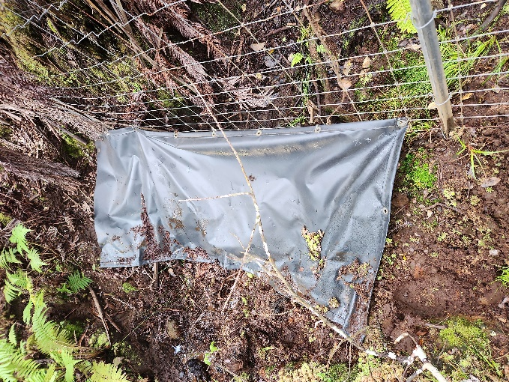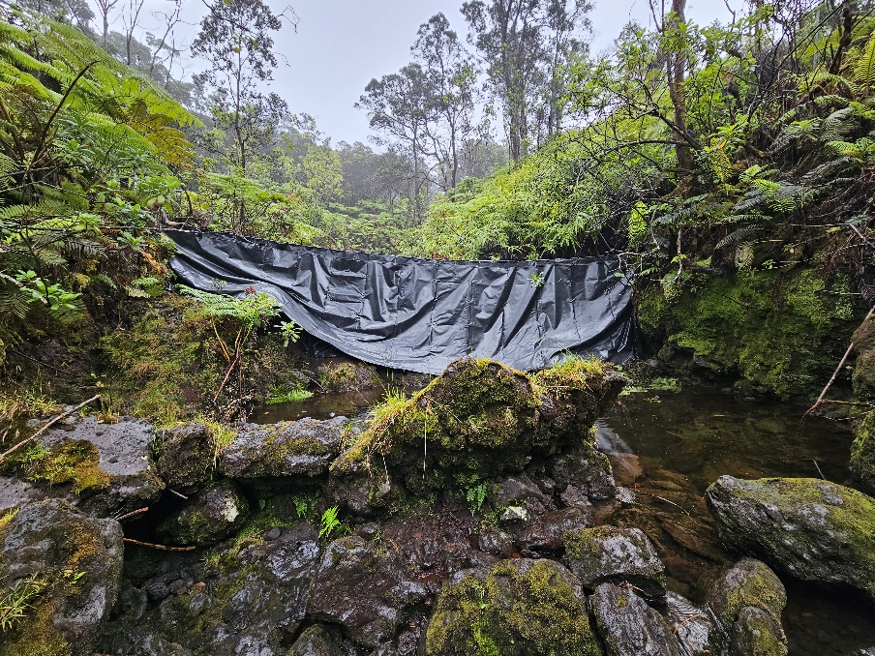
Typical tarp on fence in Kaʻū
Largest tarp crossing in Kaʻū Preserve

- Skirting
The bottom strand of mesh wire will be fastened to each t-post so that it is flush with the ground surface or no more than one (1”) inch above the ground at any point along the fence and fastened to the ground with appropriate anchors. This criterion will be scrutinized during inspections prior to payment. If anchors cannot close a gap greater than one (1”) in between the bottom strand and the ground an apron must be installed.
Skirting shall be 32” high tensile woven wire. The apron should overlap along the bottom of the fence by 2 rows of squares or maximum 1 foot and attached so that the overlapping squares are positioned vertically over the panel and the remaining hog wire is stretched horizontally over the ground on the outside of the fence.
Skirting shall be attached to the wire mesh using hog rings. One hog ring shall be used per square of mesh and attached to the panel in an alternating pattern between the bottom of the wire and the bottom of the fence. Apron should extend 1 ½ feet beyond the vertical plane of the fence. The edge of skirting will be secured with appropriate anchors. A tie wire shall be attached to the anchor through the hole provided in the pin and then tied to the apron. Anchors shall be spaced no more than 15 feet apart. To the greatest extent possible, anchors must be buried in the ground. Terrain will dictate the number of anchors required per length of skirt.
For this IFB, the ground surface is the soil surface and not the vegetation mat. The vegetation mat and loose soil will be manually cleared as needed to ensure the above specifications are met. In cases of rugged and severe undulating pahoehoe and ʻAʻā lava, skirting will be required to maintain the cumulative 48” height of fence and tight relation to the ground. Where obstacles such as rocks or large roots appear, either these items must be removed (if approved by DOFAW staff) or the apron must be installed to fit tightly around these surface irregularities.
6. Hog rings
Hog rings shall be used to secure the apron or tarp to the bottom of the wire fence as described in the apron and tarp section above.
7. Clips
Clips shall be twisted tight enough to be secure. Over tightening to the extent of damaging the smooth wire or causing the clips to break is not acceptable. Both ends of the fence clips shall be properly tightened so that clips are not loose and there is no play between the clip and the T-post. Wire mesh shall be attached with clips to each post by the top and bottom wire and at least three (3) interior wires (at least 5 for 75 inch fence). Clips shall be Bezinal coated.
8. Anchors
Anchors to ensure that the gap between the bottom strand of the wire mesh and the ground is no more than one (1”) inch may be T-posts (T-133), concrete forming pins, or hot-dipped galvanized eyebolts and will depend on the substrate. All Anchors shall be installed on the interior of the fence unit. All anchor options will be provided by the State.
T-post anchors will be driven at a 30 to 45-degree angle such that the tops are no more than 2 (2”) inches off the centerline and that no more than three (3”) inches is protruding from the ground surface. Posts will be attached to at least two (2) of the bottom strands of woven wire with 9-gauge wire. Post will be driven to pull the tie tight. Use T-posts if soil substrate is at least two (2’) feet deep and relatively soft.
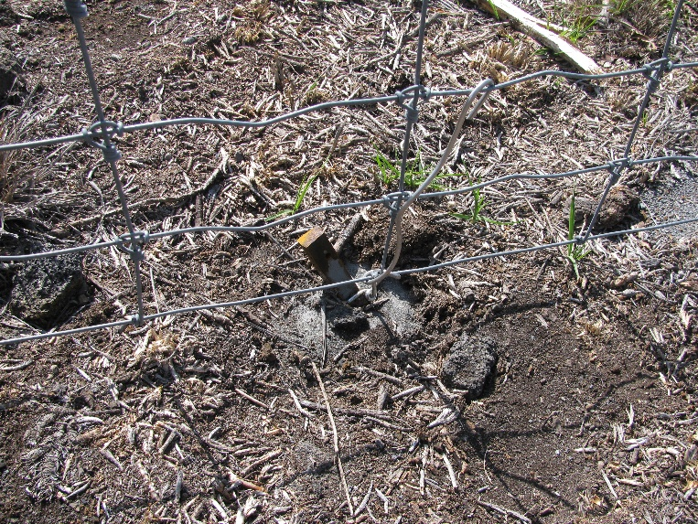
Concrete forming pins will be driven at a 30 to 45-degree angle such that tops are no more than four (4”) inches off the centerline of the fence and no more than three (3”) inches is protruding from the ground surface. Pins will be attached to at least two (2) of the bottom strands of woven wire with 9-gauge wire. All 9-guage wire should be tied to a vertical and horizontal strand of woven wire to ensure a uniform downward pull. Pins will be driven down to pull the tie tight. Pins must be installed such that they do not contact the woven wire of the fence. Pins should be used if soil substrate is less than two (2’) feet deep or substrate is rocky or hard packed.
Proper use of concrete pin to anchor fence down. Notice the pin does not contact the woven wire.

9. Pedestrian Gates
Self-closing step through pedestrian gates: Will be provided to the Contractor. Gates will be a minimum of 48” working height with additional 6” stub-outs on bottom. Total length of vertical pipes will be 81” minimum, 96” maximum – single piece pipe (not welded). Total width is 36” with a swinging gate 28” W by 36” H. There should be a 32” high fixed step over. 2” x 4” square steel dipped galvanized paneling will be used for fixed gate mesh portions. Perimeter pipe will be 2 3/8” OD Schedule 40 galvanized steel pipe. Gate will be designed as a self-closing gate, using heavy duty weather resistant Tru-close hinges or equivalent. All hardware will be galvanized included any screws, bolts or mounting hardware. Gate will swing in only one direction and have a gate stop. The step over must allow human traffic and yet prevent ungulates from crossing (See Pedestrian Gate Diagram and picture examples below).
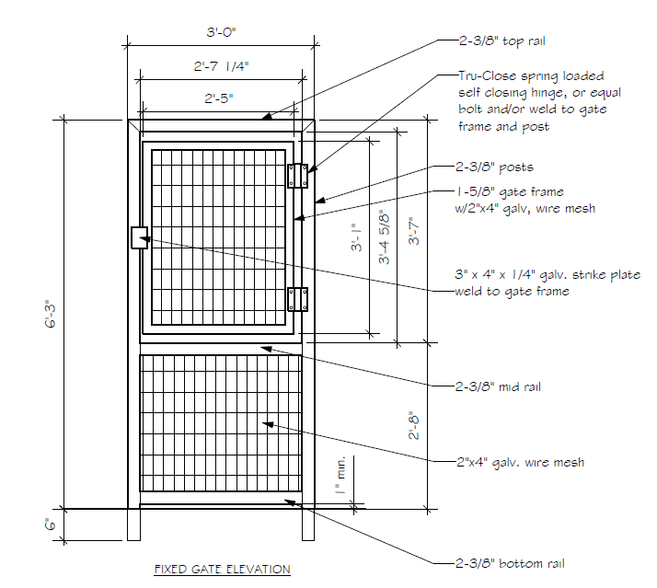
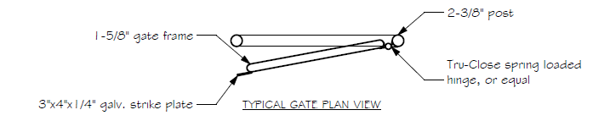
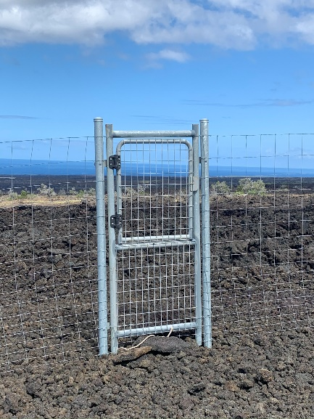
Vehicle gate: The opening for the vehicle gate should be no less than 8.5’ wide, enough to accommodate one approximately 8’ gate hung so that there is no more than 2” between the gate and the hinge posts, and the ground. Gates should be a total height of 48" above the ground and be within 1-2” of the ground. They should be made from 2” Schedule 40 galvanized pipe with High Five Coral Panel covering entire gate. Contractor will provide shop drawings of the gate showing proposed construction for approval. All welds and drilled areas will be protected with cold galvanized spray. The gate shall be installed to swing at least 90 degrees from the closed position. The hinges will be industrial pressed steel 180-degree u-bolt style and welded to the hinge post once installation is complete. Three hinges should be used on each gate/post and equally spaced from the ground up. To ensure close contact with uneven ground, gates may require a skirt of High Five Corral Panel material that extends 12” or less below the bottom of the bottom horizontal pipe which is cut to follow the ground contour. This skirt should be attached securely or integrated into the gate design so that it is secure and cannot be pressed inward by animals. Hinge posts will be 3" diameter galvanized pipe buried at least 36” in the ground with 3" ball cap. The hinge post should be braced with a horizontal pipe of 2 3/8” OD to a vertical pipe of 2 7/8” OD according to H-brace specifications, but joints in these braces should be welded instead of attached using hardware. The vertical members of the gate braces shall be at least 3' below grade in concrete to withstand a 300-pound pull against the top. Posts shall be erected plumb. Holes for vertical posts shall be 3'-6” deep x 16" wide and filled with concrete. Concrete shall be job-mixed, maximum slump four (4) inches. Proportion will be of one-part cement, two-parts fine aggregate, three-parts coarse aggregate, using a minimum of six bags of cement per cubic yard. Water content, maximum of 5 3⁄4 gallons per bag cement, including water contained in aggregate. Or use Quickrete or equivalent mixed according to manufacturer’s instructions. (See gate diagram).
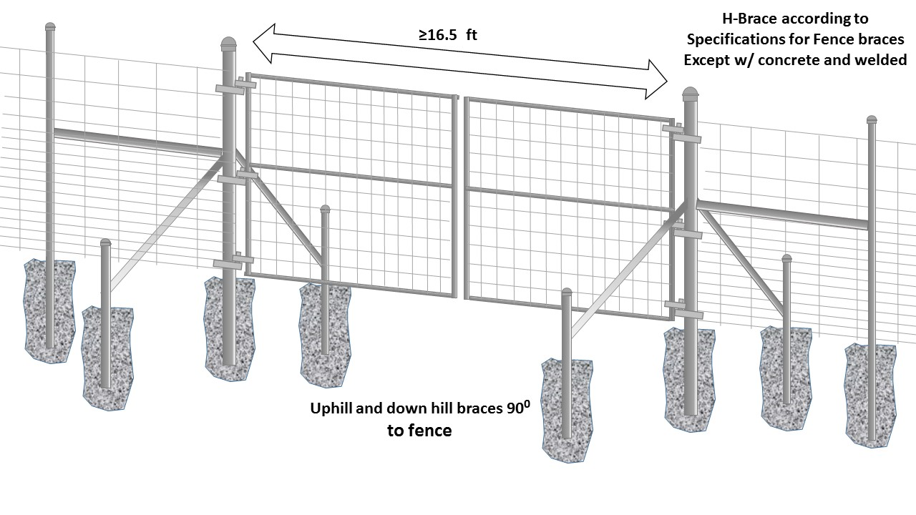
Vehicular gate diagram for the Fence Project Area (Note that two panels are shown, with only one being called for to construct a 8 foot vehicle gate).

Pre-Installation Conference:

Contractor shall meet with staff from DOFAW soon after the award, if any. Topics to be included at the meeting will be:
- Designation of responsible officials
- Correspondence procedures
- Labor standard provisions
- Changes in specifications
- Payments to The Contractor
- Safety program
- ROD Sanitation SOP
- Communication
- Installation techniques
- Helicopter transport
- Fence removal staging locations
- Proposed installation schedule
- Camping guidelines and restrictions
- Alien plants and animal precautions
- Miscellaneous

Written Inquiries
Inquiries regarding this solicitation are due no later than the date indicated in the timeline. Inquiries shall be made in writing by e-mail to Emma.Yuen@hawaii.gov.
The State will respond to questions in writing by the date indicated in the timeline. Written inquiries received after the date indicated in the timeline may be responded to at the discretion of the State.
TERMS AND CONDITIONS
Authority of the State:
The State shall decide all questions that may arise as to the work performed hereunder, as to the manner of such performance, as to the interpretation of any law, rule or regulation, policies and procedures, as to compensation, and as to any other matter that may arise under the Contract. The decision of the State in such matters shall be final if not in violation of law and not arbitrary, capricious or characterized by abuse of discretion.

Bidder Qualifications:
Bidder shall provide Bid Security in acceptable form pursuant to HRS 103D-323 and HAR 3-122-222. Bid Security must be submitted BERORE Offer Due Date & Time.
Offer Form:
Bidder is requested to submit its offer using the exact legal name of the business as registered with the Department of Commerce and Consumer Affairs, if applicable; and to indicate exact legal name in the appropriate space on Offer Form. Failure to do so may delay proper execution of the contract. All offers must contain all pages of the offer form packet including any schematics requested by this IFB.
The authorized signature on the first page of the Offer Form shall be an original signature in ink, which shall be required before an award, if any, can be made. The signed Offer Form shall indicate bidder’s intent to be bound. Please upload a copy when submitting bid on HIePRO, Retain the original to submit if selected for award.
Contract Administrator (CA):
Emma Yuen, Natural Resources Management Program Specialist, DOFAW, is the Contractor Administrator and can be reached at Emma.Yuen@hawaii.gov or (808) 366-4788.
The State may change the Contractor Administrator or delegate at any time. TNC’s representative for this project is Chris Balzotti, who can be reached at c.s.balzotti@tnc.org or (801) 857-1271.
Method of Award:
Offers must be submitted through the State of Hawaiʻi eProcurement (HIePRO) system. At the close of this solicitation the bids will be reviewed by the Contractor Administrator. Award will be made to the lowest responsive responsible bid. All vendors are advised that they must be HCE compliant within 10 calendar days of the closing of the HIePRO solicitation. If the vendor is not compliant, the State has the option of extending the deadline to become compliant or rejecting that bidder and awarding to the second lowest bidder. The bidder must provide a bid for all line items in the solicitation to qualify for award. The lowest bid will be determined by weighting the item prices using the following formula:
TNC Kona Hema Project Item No. | Unit Price | Multiplied by estimated quantity | Cost
1. Mobilization Fee* (1 move) |  | 1
2. Per ft cost for Project (fence installation) |  | 3,234
3. Per ft cost for Project (wire replacement) |  | 32,431
4. Pedestrian Gate |  | 1
5. Vehicular Gate (8’) |  | 1
TOTAL COST

TNC Kaʻū Project Item No. | Unit Price | Multiplied by estimated quantity | Cost
6. Mobilization Fee* (1 move) |  | 1
7. Per ft cost for Project |  | 14,324
8. Pedestrian Gate |  | 6
9. Tarp replacement and addition |  | 60
TOTAL COST

* “Mobilization fee” will be procured if needed only in the case of unforeseen circumstances arising due to the State changing the scope of the project.
Vendor Selection:
Vendor must provide the unit price for every item number, for one or both projects, in order to bid. The vendor with the lowest total cost per fence project (sum of all costs based on estimated quantity) will be selected. Two different vendors may be awarded if there is a different low bidder for the second project. All offers must be submitted by the date indicated by the timeline. No late submittals will be accepted. The offer must include all Offer form Pages including the schematics for gates and step overs.
Contract:
The successful bidder will enter a contract with the State for the line item prices identified by this solicitation. The term of the contract will be for 24 months from the date on the Notice to Proceed. Upon mutual agreement of both parties and the availability of funds this contract may be extended up to two (2) additional 12-month periods.
Notice of Award:
Upon execution of the contract the Contractor Administrator will issue a written Notice of Award. However, no work shall commence. This will be notification that the contract has been successfully executed. Finalization of the contract does not guarantee that all sections of the fence will be procured. The State may purchase more or less of the fence as quantities listed are estimates and subject to change.
Fence Projects:
After Notice of Award has been issued DOFAW will work with the Contractor to encumber the funds with a State of Hawaiʻi Purchase Order (PO) for each section. Fence sections (per LF cost) will be ordered on an as needed basis, with payment by PO. For every PO, the Contractor will be required to submit two (2) bonds, a performance bond and labor and material payment bond for 100% of the PO price. The State will prepare a PO for the desired quantities of each line item and provide to the Contractor. The Contractor will provide the required performance bond and labor and material payment bonding and DOFAW will submit for processing. After the PO has been approved and the required bonds received, DOFAW will issue a Notice to Proceed to the Contractor and work on that fence section may begin. For every mile requisitioned by the State via PO, the Contractor will have six (6) months to complete. The State has the discretion to allow extensions if the bidder submits requests in writing at least 30 days prior to the end of the six (6) month period.
Payment:
Payment will be made with a State of Hawaiʻi Purchase Order (PO). Partial payments may be invoiced every 30 days, at the completion of a line item, or at the completion of a project. Completed fence will be measured on site by DOFAW staff and inspected for compliance with specifications before payment.
General Conditions:
It is understood that the contract includes Forms AG-008 General Conditions and AG-015 Special Conditions.
The Department of Land and Natural Resources Interim General Conditions dated October 1994, as amended, shall be made a part of these contract specifications and are referred to hereafter as the DLNR Interim General Conditions.
In the event of a conflict between conditions, Special Conditions shall take precedence, followed by the General Conditions, and the DLNR Interim General Conditions.
Chapter 104, HRS, Wages and Hours of Employees on Public Works:
Bidder is advised that Chapter 104, HRS shall apply to this solicitation. The Bidder may access this Chapter on the State's website: www.ehawaiigov.org/government/html/index.html.
**Awarded contractor will provide weekly certified payroll to the Contractor Administrator. **
Subcontractors:
Bidder shall provide the name and contact information for any subcontractor to be used on the project. Failure to provide this information shall be grounds for bid rejection.
Contractor’s License: A contractor’s license is NOT required for this job.
Insurance:
Bidder shall provide proof of insurance including: the insurance agent (company name), contact person and phone number, the insurance underwriter, and the policy number. Failure to provide such information shall be grounds for bid rejection.
LIABILITY INSURANCE
The Contractor shall maintain in full force and effect during the life of this contract, liability and property damage insurance to protect The Contractor and his subcontractors, if any, from claims for damages for personal injury, accidental death and property damage which may arise from operations under this contract, whether such operations be by himself or by a subcontractor or anyone directly or indirectly employed by either of them. If any subcontractor is involved in the performance of the contract, the insurance policy or policies shall name the subcontractor as additional insured.
As an alternative to The Contractor providing insurance to cover operations performed by a subcontractor and naming the subcontractor as additional insured, The Contractor may require the subcontractor(s) to provide its own insurance which meets the requirements herein. It is understood that a subcontractor's insurance policy or policies are in addition to the Contractor's own policy or policies.
The following minimum insurance coverage(s) and limit(s) shall be provided by the Contractor,
Including its subcontractor(s) where appropriate.
Coverage Limits
Commercial General Liability $2,000,000 combined single
(Occurrence form) limit per occurrence for bodily
Injury and property damage

Basic Motor Vehicle Insurance BI: $1,000,000 per person
And Liability Policies $1,000,000 per accident
PD: $1,000,000 per accident

Each insurance policy required by this contract, including a subcontractor's policy, shall contain the following clauses:
1. "This insurance shall not be canceled, limited in scope of coverage or non-renewed until after 30 days written notice has been given to the State of Hawaiʻi, Department of Land and Natural Resources, Division of Forestry and Wildlife,1151 Punchbowl Street, Room 325, Honolulu, Hawaiʻi 96813."
2. "The State of Hawaiʻi is added as an additional insured as respects to operations performed for the State of Hawaiʻi."
3. "It is agreed that any insurance maintained by the State of Hawaiʻi will apply in excess of, and not contribute with, insurance provided by this policy."
4. The Contractor may use umbrella or excess policies to provide the liability limits as required in this Contract. The umbrella or excess policies shall be provided on a true “following form” or broader coverage basis, with coverage at least as broad as provided on the underlying commercial general liability insurance. Before any of the Services commence, the foregoing requirements must be evidenced by one or more certificates of insurance, showing TNC as an additional named insured on the commercial general liability policy and requiring at least 30 days advance written notice to TNC of any cancellation, renewal, reduction in limits, or coverage or other material change of the policies. TNC reserves the right to request additional documentation, such as one or more policy endorsements, deemed reasonably necessary to ensure such requirements have been met.

The minimum insurance required shall be in full compliance with the Hawaiʻi Insurance Code throughout the entire term of the contract, including supplemental agreements.
Upon Contractor's execution of the contract, the Contractor agrees to deposit with the State of Hawaiʻi certificate(s) of insurance necessary to satisfy the State that the insurance provisions of this contract have been complied with and to keep such insurance in effect and the certificate(s) therefore on deposit with the State during the entire term of this contract, including those of its subcontractor(s), where appropriate. Upon request by the State, the Contractor shall be responsible for furnishing a copy of the policy or policies.
Failure of the Contractor to provide and keep in force such insurance shall be regarded as material default under this contract, entitling the State to exercise any or all of the remedies provided in this contract for a default of the Contractor.
The procuring of such required insurance shall not be construed to limit the Contractor's liability hereunder or to fulfill the indemnification provisions and requirements of this contract. Notwithstanding said policy or policies of insurance, the Contractor shall be obliged for the full and total amount of any damage, injury, or loss caused by negligence or neglect connected with this contract.
Irregular Bids:
No irregular bids or propositions for doing the work will be considered by the Board.
Withdrawal of Bid:
No bidder may withdraw their bid between the time of the opening thereof and the award of contract.
Successful Bidder to file Performance and Payment Bonds:
The successful bidder will be required to file performance bonds and labor and material payment bonds each for the total amount of each project price requisitioned by a purchase order per the “fence projects” section.
Change Orders:
No work of any kind in connection with the work covered by the plans and specifications shall be considered as change order work, or entitle the Contractor to extra compensation, except when the work has been ordered in writing by the Contractor Administrator and in accordance with sub-section 4.2 of the DLNR Interim General Conditions.
The Contractor shall clearly identify and inform the Contract Administrator in writing of any deviations from the contract documents at the time of submission and shall obtain the Contract Administrator’s written approval to the specified deviation prior to proceeding with any work.
Wages and Hours:
In accordance with sub-sections 7.3 to 7.9 of the DLNR Interim General Conditions relative to hours of labor, minimum wages and overtime pay, the current minimum wage rates promulgated by the Department of Labor and Industrial Relations (DLIR) shall be paid to the various classes of laborers and mechanics engaged in the performance of this contract on the job site. The minimum wages shall be increased during the performance of the contract in an amount equal to the increase in the prevailing wages for those kinds of work as periodically determined by the DLIR.
The Department of Land and Natural Resources will not recognize any claim for additional compensation because of the payment by The Contractor of any wage rate in excess of the said minimum wage rates. The possibility of wage increase is one of the elements to be considered by The Contractor in determining his Bid, and will not, under any circumstances, be considered as the basis of a claim against the Department under this Contract.
No work shall be done on Saturdays, Sundays, legal State holidays, and/or in excess of eight (8) hours each day without the written consent of the Contract Administrator. Should permission be granted to work at such times, the Contractor shall pay for all inspection administrative costs thereof. No work shall be done at night unless authorized by the Contract Administrator. This project is located within a remote region that may require work on Saturdays, Sundays, legal State holidays, and/or in excess of eight (8) hours each day, and/or at night. Work during these times will be permitted subject to approval by the Contract Administrator.
Property Damage:
It shall be the responsibility of the Contractor to respect State and TNC property and to prevent damage to existing improvements. The Contractor will be responsible for damages resulting from construction operations. Immediately upon discovery, the Contractor shall repair such damage to the satisfaction of the Contract Administrator.
All trees and shrubbery outside the excavation, embankment or construction limits shall be fully protected from injury.
Bidder’s Responsibility to Provide Proper Superintendence:
The successful low bidder shall designate in writing to the Contract Administrator the name of its authorized superintendent (Superintendent), who will be present at the job site whenever any work is in progress. The Superintendent shall be responsible for all work, receiving and implementing instructions from the Contract Administrator in a timely manner. The cost for superintendence shall be considered incidental to the project.
If the Superintendent is not present at the site of work, the Contract Administrator shall have the right to suspend the work as described under sub-section 5.5 c. and 7.20 - Suspension of Work of the DLNR Interim General Conditions.
Hiring of Hawaiʻi Residents:
The Contractor shall comply with Act 68, SLH 2010, in the performance of; and for the duration of this contract. The Contractor shall ensure that Hawaiʻi residents compose not less than eighty percent of the workforce employed to perform the contract work on the project. The eighty percent requirement shall be determined by dividing the total number of hours worked on the contract by Hawaiʻi residents, by the total number of hours worked on the contract by all employees of the Contractor in the performance of the contract. The hours worked by any Subcontractor of the Contractor shall count towards the calculation for this section. The hours worked by employees with shortage trades, as determined by the Department of Labor and Industrial Relations (DLIR), shall not be included in the calculation for this section.
The requirements shall apply to any subcontract of $50,000 or more in connection with the Contractor, that is, such Subcontractors must also ensure that Hawaiʻi residents compose not less than eighty percent of the Subcontractor’s workforce used to perform the subcontract.
Public Convenience and Safety:
The Contractor shall conduct construction operations with due regard to the convenience and safety of the public at all times. No materials or equipment shall be stored where it will interfere with the safe passage of public traffic. The Contractor Administrator shall have the right to suspend the performance of the work in accordance with sub-section 7.20 - Suspension of Work of the DLNR Interim General Conditions.
Worker Safety:
The Contractor shall provide, install and maintain in satisfactory condition all necessary protective facilities and shall take all necessary precautions for the protection and safety of its workers in accordance with the Occupational Safety and Health Standards for the State of Hawaiʻi. The Contract Administrator shall have the right to suspend the performance of the work in accordance with sub-section 7.20 - Suspension of Work of the DLNR Interim General Conditions.
Other Health Measures:
Forms of work site exposure or conditions which may be detrimental to the health or welfare of workers or of the general public shall be eliminated or reduced to safe levels as required by the DOH codes, standards, and regulations. Suitable first aid kits and a person qualified to render first aid, as specified in the DOH regulations, shall be provided at all times when work is scheduled.
Hawaiʻi Business or Compliant Non-Hawaiʻi Business Requirement:
Bidders (Contractors) shall be incorporated or organized under the laws of the State or be registered to do business in the State as a separate branch or division that is capable of fully performing under the contract, as stipulated in §3-122-112 HAR.
Compliance with §3-122-112 HAR:
As a condition for award of the contract and as proof of compliance with the requirements of 103D-310(c) HRS, the selected bidder shall furnish the required documents to the Department. If the valid required certificates are not submitted on a timely basis for award of a contract, a bidder otherwise responsive and responsible may not receive the award. Bidder is responsible to apply for and submit the following documents to the Department.
A. TAX CLEARANCE REQUIREMENTS (HRS Chapter 237): Bidder shall obtain a tax clearance certificate from the Hawaiʻi State Department of Taxation (DOTAX) and the Internal Revenue Service (IRS). The certificate is valid for six months from the most recently approved stamp date on the certificate; the certificate must be valid on the date received by the Department.
B. Department of Labor (DLIR) “Certificate of Compliance”. (HRS Chapter 383 - Unemployment Insurance, Chapter 386 - Workers’ Compensation, Chapter 392 - Temporary Disability Insurance, and 393 – Prepaid Health Care): Bidder shall obtain a certificate of compliance from the Hawaiʻi State Department of Labor and Industrial relations (DLIR). The certificate is valid for six months from the date of issue; certificates must be valid on the date received by the Department.
C. Department of Commerce and Consumer Affairs (DCCA), Business Registration Division (BREG) “Certificate of Good Standing”. Bidder shall obtain a certificate of good standing issued by the Department of Commerce and Consumer Affairs (DCCA), Business Registration Division (BREG). The certificate of good standing is valid for six months from the date of issue; certificates must be valid on the date received by the Department.
Preferably, instead of separately applying for these certificates at the various state agencies, bidder may choose to use the Hawaiʻi Compliance Express (HCE), which allows businesses to register online through a simple wizard interface at http://vendors.ehawaii.gov to acquire a “Certificate of Vendor Compliance” indicating the bidder’s status is compliant with the requirements of §103D-310(c), HRS, and shall be accepted for contracting and final payment purposes. Bidders that elect to use the new HCE services will be required to pay an annual fee of $15.00 to the Hawaiʻi Information Consortium, LLC (HIC).
Campaign Contributions:
Contractors are hereby notified of the applicability of Section 11-355, HRS, which states that campaign contributions are prohibited from specified State or county government contractors during the term of the contract if the Contractors are paid with funds appropriated by a legislative body.
Protest:
A protest shall be submitted in writing within five (5) working days after the aggrieved person knows, or should have known, of the facts giving rise thereto; provided that a protest based upon the content of the solicitation shall be submitted in writing prior to the date set for receipt of offers. Further provided that a protest of an award or proposed award shall be submitted within five (5) working days after the posting of award of the contract.
Any protest pursuant to §103D-701, HRS, and Section 3-126-3, HAR, shall be submitted in writing to the Chair of the Department of Land and Natural Resources, 1151 Punchbowl Street, Honolulu, Hawaiʻi 96813 or P. O. Box 621, Honolulu, Hawaiʻi 96810-0119.

OFFER FORM

Fence Installation and Replacement in the Kona Hema Preserve and Kaʻū Preserve
Hawaiʻi Island

Emma Yuen
Department of Land and Natural Resources
Division of Forestry & Wildlife
State of Hawaiʻi
1151 Punchbowl St. Rm. 325
Honolulu, HI 967813

Dear Sir/Madam:

The undersigned has carefully read and understands the terms and conditions specified in the Specifications and Special Provisions attached hereto SPO GENERAL PROVISIONS and the AG General Conditions, Form AG-008 as revised attached separately; and hereby submits the following offer to perform the work specified herein, all in accordance with the true intent and meaning thereof. The undersigned further understands and agrees that by submitting this offer, 1) he/she is declaring his/her offer is not in violation of Chapter 84, Hawaiʻi Revised Statutes, concerning prohibited State contracts, and 2) he/she is certifying that the price(s) submitted was (were) independently arrived at without collusion.

Offeror is:
☐ Sole Proprietor ☐ Partnership ☐ *Corporation ☐ Joint Venture
☐ Other
*State of incorporation:

Hawaiʻi General Excise Tax License I.D. No.

Payment address (other than street address below):
City, State, Zip Code:

Businesses address (street address):
City, State, Zip Code:

Respectfully submitted:

Date: (x)
Authorized (Original) Signature
Telephone No.:

Fax No.: Name and Title (Please Type or Print)

E-mail Address: **
Exact Legal Name of Company (Offeror)

**If Offeror is a “dba” or a “division” of a corporation, furnish the exact legal name of the corporation under which the awarded contract will be executed:

TNC Kona Hema Project Item No. | Unit Price | Multiplied by estimated quantity | Cost
1. Mobilization Fee* (1 move) |  | 1
2. Per ft cost for Project (fence installation) |  | 3,234
3. Per ft cost for Project (wire replacement) |  | 32,431
4. Pedestrian Gate |  | 1
5. Vehicular Gate (8’) |  | 1
TOTAL COST

TNC Kaʻū Project Item No. | Unit Price | Multiplied by estimated quantity | Cost
6. Mobilization Fee* (1 move) |  | 1
7. Per ft cost for Project |  | 14,324
8. Pedestrian Gate |  | 6
9. Tarps |  | 60
TOTAL COST

* “Mobilization fee” will be procured if needed only in the case of unforeseen circumstances arising due to the State changing the scope of the project.
Offeror:
Name of Company

OFFEROR SHALL FURNISH THE FOLLOWING INFORMATION:

Company Name:

Company Address:

Telephone Number: Fax Number:

E-Mail Address:

Contact Person:

Commercial General Liability Insurance:

Insurance Agent (Company Name): _______________________________________________

Contact Person: Contact No.: ___________

Insurance Underwriter: _________________________________________________________

Policy No.: ______________________________

Subcontractors: If Offeror is using subcontractors for this project, Offeror shall provide the following information for each subcontractor:

1) _____________________________________________________________________
Name Address

_____________________________________________________________________
Contact Name Contact Phone Number

2) _____________________________________________________________________
Name Address

_____________________________________________________________________
Contact Name Contact Phone Number

3) _____________________________________________________________________
Name Address

_____________________________________________________________________
Contact Name Contact Phone Number

Information on previous fence jobs:

- Project 1
  - Location:____________
  - Date Completed:____________
  - Length:____________
  - Reference:____________

- Project 2
  - Location:____________
  - Date Completed:____________
  - Length:____________
  - Reference:____________

Offeror____________________________
Name of Company

WAGE CERTIFICATE
FOR SERVICE CONTRACTS
(See Special Provisions)

Subject: IFB No: TNC-KH-KAʻŪ-FENCES-25

Title of IFB: Fence Installation and Replacement in the Kona Hema Preserve and Kaʻū Preserve,
Hawaiʻi Island
Pursuant to Section 103-55, Hawaiʻi Revised Statutes (HRS), I hereby certify that if awarded the contract in excess of $25,000.00, the services to be performed will be performed under the following conditions:

- All applicable laws of the federal and state governments relating to workers’ compensation, unemployment compensation, payment of wages, and safety will be fully complied with; and

- The services to be rendered shall be performed by employees paid at wages or salaries not less than the wages paid to public officers and employees for similar work, with the exception of professional, managerial, supervisory, and clerical personnel who are not covered by Section 103-55, HRS.

I understand that failure to comply with the above conditions during the period of the contract shall result in cancellation of the contract, unless such noncompliance is corrected within a reasonable period as determined by the procurement officer. Payment in the final settlement of the contract or the release of bonds, if applicable, or both shall not be made unless the procurement officer has determined that the noncompliance has been corrected; and

I further understand that all payments required by Federal and State laws to be made by employers for the benefit of their employees are to be paid in addition to the base wage required by section 103-55, HRS

Offeror____________________

Signature__________________

Title______________________

Date______________________

CERTIFICATION OF COMPLIANCE FOR FINAL PAYMENT
(Reference §3-122-112, HAR)

Reference: _______________________________ TNC KH-KAʻŪ-FENCES-25_________________
(Contract Number) (IFB/RFP Number)

_ Affirms it is in
(Company Name)
Compliance with all laws, as applicable, governing doing business in the State of Hawaiʻi to include the following:

1. Chapter 383, HRS, Hawaiʻi Employment Security Law – Unemployment
Insurance;
2. Chapter 386, HRS, Worker’s Compensation Law;
3. Chapter 392, HRS, Temporary Disability Insurance;
4. Chapter 393, HRS, Prepaid Health Care Act; and

Maintains a “Certificate of Good Standing” from the Department of Commerce and Consumer
Affairs, Business Registration Division.

Moreover,
(Company Name)
Acknowledges that making a false statement shall cause its suspension and may cause its debarment from future awards of contracts.

Signature:

Print Name:

Title:

Date:

TAX EQUALIZATION CERTIFICATE

SUBJ: Offer No: TNC-KH-KAʻŪ-FENCES-25

Description: The Nature Conservancy’s Kona Hema Preserve and Kaʻū Preserve Fence Installation and Repair Project
Out-of-State Offerors not possessing a Hawaiʻi General Excise Tax (GET) license must answer all questions:
Yes No
(Check only one)
1. Does your business have an office, inventory,
property, employees, or other representation in
the State of Hawaiʻi (hereinafter SOH)? __ _

2. Does the contract to be awarded require your
business to have an office, inventory, property,
employees, or other representation in the SOH? _ _
3. Does your business provide services in conjunction
with the sales of property, such as training,
installation, or repairs in the SOH? _ _

4. Will your business provide any services in the
SOH under the contract to be awarded? __ __*

*If the entire services are to be subcontracted, subject to the State's approval, provide the names of the subcontractor(s):

If you answered "Yes" to any question, then you have sufficient presence in the State and are advised that the gross receipts derived from this solicitation are subject to the GET imposed by

Chapter 237, HRS, at the current 4% or 4.5%* rate, and where applicable to tangible property imported into the SOH for resale, subject to the current 1/2% use tax imposed by Chapter 238, HRS.

If you answered "No" to all questions, then the tax equalization provision described in Section 103D-1008, HRS, applies to you.

Offeror _

Signature _

Title _
Date _

COMBINATION PERFORMANCE AND PAYMENT BOND
KNOW TO ALL BY THESE PRESENTS:

That we, ______________________________________________________________,
(Full Legal Name and Street Address of Contractor)
as Contractor, hereinafter called Principal, and ______________________________________
___________________________________________________________________________,
(Name and Street Address of Bonding Company)
as surety, hereinafter called Surety, a corporation(s) authorized to transact business as a
surety in the State of Hawaiʻi, are held and firmly bound unto the _______________________,
(State/County Entity)
its successors and assigns, as Obligee, hereinafter called Obligee, in the amount of
____________________________________________________________________________
(Twice the Dollar Amount of Contract)
DOLLARS ($______________) (being _____________________________________________
DOLLARS as performance bond and ______________________________________________
DOLLARS as payment bond, each in the amount of one hundred percent of the contract price as required by 103D-324, Haw. Rev. Stat.), lawful money of the United States of America, for the payment of which to the said Obligee, well and truly to be made, Contractor and Surety bind ourselves, our heirs, executors, administrators, successors and assigns, jointly and severally, firmly by these presents.
WHEREAS:
The Principal has by written agreement dated _____________ signed a contract with Obligee for the following Project: _________________________________________________
_______________________________________________________________________________________________________________________________________________________________________________________________________________________________________________________________________________________________________________,
hereinafter called Contract, which Contract is incorporated herein by reference and made a part hereof.
NOW, THEREFORE,
The condition of this obligation is such that, if Principal shall promptly and faithfully perform the Contract in accordance with, in all respects, the stipulations, agreements, covenants and conditions of the Contract as it now exists or may be modified according to its terms, and shall deliver the Project to the Obligee, or to its successors or assigns, fully completed as in the Contract specified and free from all liens and claims and without further cost, expense or charge to the Obligee, its officers, agents, successors or assigns, free and harmless from all suits or actions of every nature and kind which may be brought for or on account of any injury or damage, direct or indirect, arising or growing out of the doing of said work or the repair or maintenance thereof or the manner of doing the same or the neglect of the Principal or its agents or servants or the improper performance of the Contract by the Principal or its agents or servants or from any other cause, and shall promptly pay all persons supplying labor and materials for the performance of the Contract, then this obligation shall be void; otherwise it shall be and remain in full force and effect.
AND IT IS HEREBY STIPULATED AND AGREED that no change, extension, alteration, deduction or addition, permitted by the Contract, in or to the terms of the Contract, or the plans or specifications pertaining thereto, shall in any way affect the obligation of the Surety on this bond; and the Surety does hereby waive notice of any such change, extension, alteration, deduction or addition in or to the terms of the Contract, or the plans or specifications pertaining thereto, or in or to the said Project.
AND IT IS HEREBY STIPULATED AND AGREED that suit on this bond may be brought before a court of competent jurisdiction without a jury, and that the sum or sums specified in the said Contract as liquidated damages, if any, shall be forfeited to the Obligee, its successors or assigns, in the event of a breach of any, or all, or any part of, the covenants, agreements, conditions, or stipulations contained in the Contract or in this bond in accordance with the terms thereof.
AND IT IS HEREBY STIPULATED AND AGREED that this bond shall inure to the benefit of any and all persons entitled to file claims for labor performed or materials furnished in said work so as to give any and all such persons a right of action as contemplated by Sections 103D-324(d) and 103D-324(e), Hawaiʻi Revised Statutes.
The above-named Principal and Surety hereby jointly and severally agree with the Obligee that every person who has furnished labor or material to the Principal for the performance of the Contract who has not been paid in full therefor after ninety days from the completion and final settlement of any contract, may institute an action against the Principal and its sureties, and have their rights and claims adjudicated in the action, and judgment rendered thereon. If the full amount of the liability of the sureties on the bond is insufficient to pay the full amount of the claims, then, after paying the full amount due the Obligee, the remainder shall be distributed pro rata among the claimants. The Obligee shall not be liable for the payment of any costs or expenses of any such suit.
The amount of this bond may be reduced in accordance with and subject to section 3-122-225, Hawaiʻi Administrative Rules.
Signed this ______ day of _______________, _______.

(Seal) __________________________________
Name of Principal (Contractor)

* __________________________________
Signature

___________________________________
Title

(Seal) ___________________________________
Name of Surety

* ___________________________________
Signature

___________________________________
Title
*ALL SIGNATURES MUST BE ACKNOWLEDGED BY A NOTARY PUBLIC
EXHIBIT A

SURETY [BID] [PROPOSAL] BOND
(11/17/98)

Bond No. __________

KNOW TO ALL BY THESE PRESENTS:

That we, ________________________________________________________________,
(Full Name or Legal Title of Offeror)

as Offeror, hereinafter called Principal, and __________________________________________,
(Name of Bonding Company)

as Surety, hereinafter called Surety, a corporation authorized to transact business as a Surety

in the State of Hawaiʻi, are held and firmly bound unto __________________________________,
(State/County Entity)
as Owner, hereinafter called Owner, in the penal sum of _________________________________

_______________________________________________________________________
(Required Amount of Bid Security)

Dollars ($______________), lawful money of the United States of America, for the payment of which sum well and truly to be made, the said Principal and the said Surety bind ourselves, our heirs, executors, administrators, successors and assigns, jointly and severally, firmly by these presents.

WHEREAS:

The Principal has submitted an offer for

.
(Project by Number and Brief Description)

NOW, THEREFORE:

The condition of this obligation is such that if the Owner shall reject said offer, or in the alternate, accept the offer of the Principal and the Principal shall enter into a Contract with the Owner in accordance with the terms of such offer, and give such bond or bonds as may be specified in the solicitation or Contract Documents with good and sufficient surety for the faithful performance of such Contract and for the prompt payment of labor and material furnished in the prosecution thereof as specified in the solicitation then this obligation shall be null and void, otherwise to remain in full force and effect.

Signed this _______ day of _______________, _______.

(Seal) ____________________________________
Name of Principal (Offeror)

____________________________________
Signature

____________________________________
Title

(Seal) ____________________________________
Name of Surety

____________________________________
Signature

____________________________________
Title

